St. Paul’s Lutheran Church
Wedding Handbook

Pastor

Daniel Buringrud
sjpastordan@gmail.com

Minister of Music/Organist

Karen Schiefer
716-257-3664
karenkokopelli@yahoo.com

Wedding Coordinators

Chris Sinn
Colleen Bower

---------------------------------
St. Paul’s Lutheran Church
6360 Rt. 242 E.
Ellicottville, NY 14731

Phone: 716-699-2265
Email: stpaulseville@gmail.com
Website: stpaulsellicottville.com

Dear Wedding Couple,
Congratulations on your upcoming wedding!
This is an exciting time for you! We are pleased that you are considering St. Paul’s Lutheran Church as the Christian setting for this special event in your lives. Our wedding staff and I will assist you in planning your wedding and making it a most memorable day for you. We believe that marriage is the delightful creation of family, which God blesses. We want to help you make your wedding a true expression of your faith in God and your love for each other.
Blessings,
Pastor Daniel Buringrud

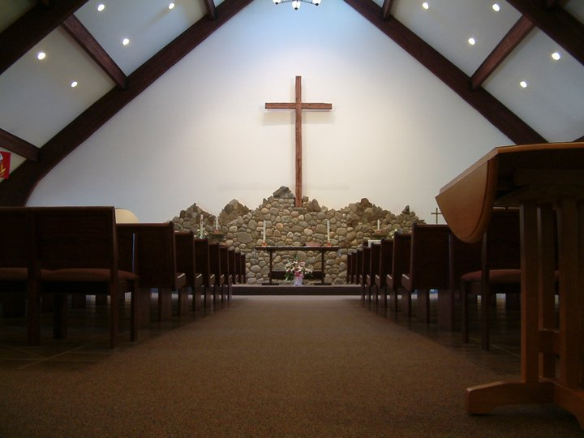

Wedding Preparation Checklist

6 months to 1 Year before your wedding~

- Choose ceremony date
- Pay deposit of $250.00

6 months before your wedding~

Meet with the Minister of Music
- Set ceremony and rehearsal time
- Tour church facilities
- Choose music selections

1 month to 2 weeks before your wedding~

Meet with Pastor
- Select Scriptures
- Final order of worship
- Address questions and concerns

1 week before your wedding~

- Turn in final payment and marriage license

1 day before your wedding~

Rehearsal~
- This will be one of the most important steps to ensure a smooth wedding ceremony. It is essential that all persons directly involved with your wedding attend the rehearsal.
- Who should attend:
~Bride & Groom
~Bridesmaids, Groomsmen, Ushers
~Child Attendants and their parents
~Parents of the couples (Grandparents welcome)
~Personal Attendants, Readers, Musicians
- Everyone should be at the church at least 15 minutes early.
- Musicians and readers do not need to practice, but they will need to know when their role takes place.

Day of your wedding~

- Bridal Party should arrive at least 45 minutes before the ceremony.
- Groomsmen should be available to seat guests 30 minutes before ceremony.
- Please be considerate of others and keep all tobacco products and alcoholic beverages off the premises.

Services and Fees

Parishioner Wedding $500
Includes: Pastor
Music
Wedding Coordinators
Janitorial Services
Church Rental Fee

Destination Wedding $1500
Includes: Pastor
Music
Wedding Coordinators
Janitorial Services
Church Rental Fee

Additional Services and Facilities

Fellowship Hall $350
This is a gathering area for post-wedding celebrations and receptions. ($250 rental fee plus $100 non-refundable cleaning deposit)

Family Lodging - (See enclosed pamphlet)
The Emmaus House, located adjacent to the church, is available for lodging. There is room for 15-20 people.

Important Information and Details

Wedding Date & Times

- Certain holidays are not available for weddings.
- Saturday weddings must begin before 3:00 PM due to the 5:00 PM church service.

Flowers

- You may use flowers of your choice to decorate the sanctuary.
- Please refrain from using open flame candles along the aisle.

Decorations and Equipment Available at St. Paul’s

- Unity candle stand
- 2 plant stands
- Guest book table

Dressing Area

- The bridal party may dress in the lower level of the church.

- The groom and groomsman may use the vesting room located in the sanctuary.

Valuables:

- Please do not leave valuables at the church.
- The church will not be responsible for lost or stolen items.

If you need additional information, please contact Pastor Dan or the Minister of Music.

We wish you peace, joy and many blessings as you plan your special day.

